COURSE FACT SHEET
PSP50922 – Diploma of Interpreting
For domestic students and non-student temporary visa holders with unlimited study right
Global Business College of Australia:
We are a vocational education and training provider committed to improving students’ practical application abilities and skills, by providing students with high quality international education services to better prepare them for the workforce.
GBCA Values: Innovative Minds, Caring Hearts, Global Skills
Course Description:
This course is designed for students who are planning to work as a paraprofessional interpreter (Mandarin - English) typically in the community and business domains.
During the program, our experienced and NAATI qualified trainers will step by step guide you through various interpreting exercises and help you to develop:
- Notes taking skills for interpreting purposes
- Short term memory retention skills
- Make sense of the briefing and quickly set up your mindset in the dialogue context
- Pick up idioms/collocations and relay in the other language correctly in a blink of eye.
- Build a comprehensive knowledge of Australian community services, and collocations/glossary in both English and Mandarin.
- And many more skills...
Industry endorsement
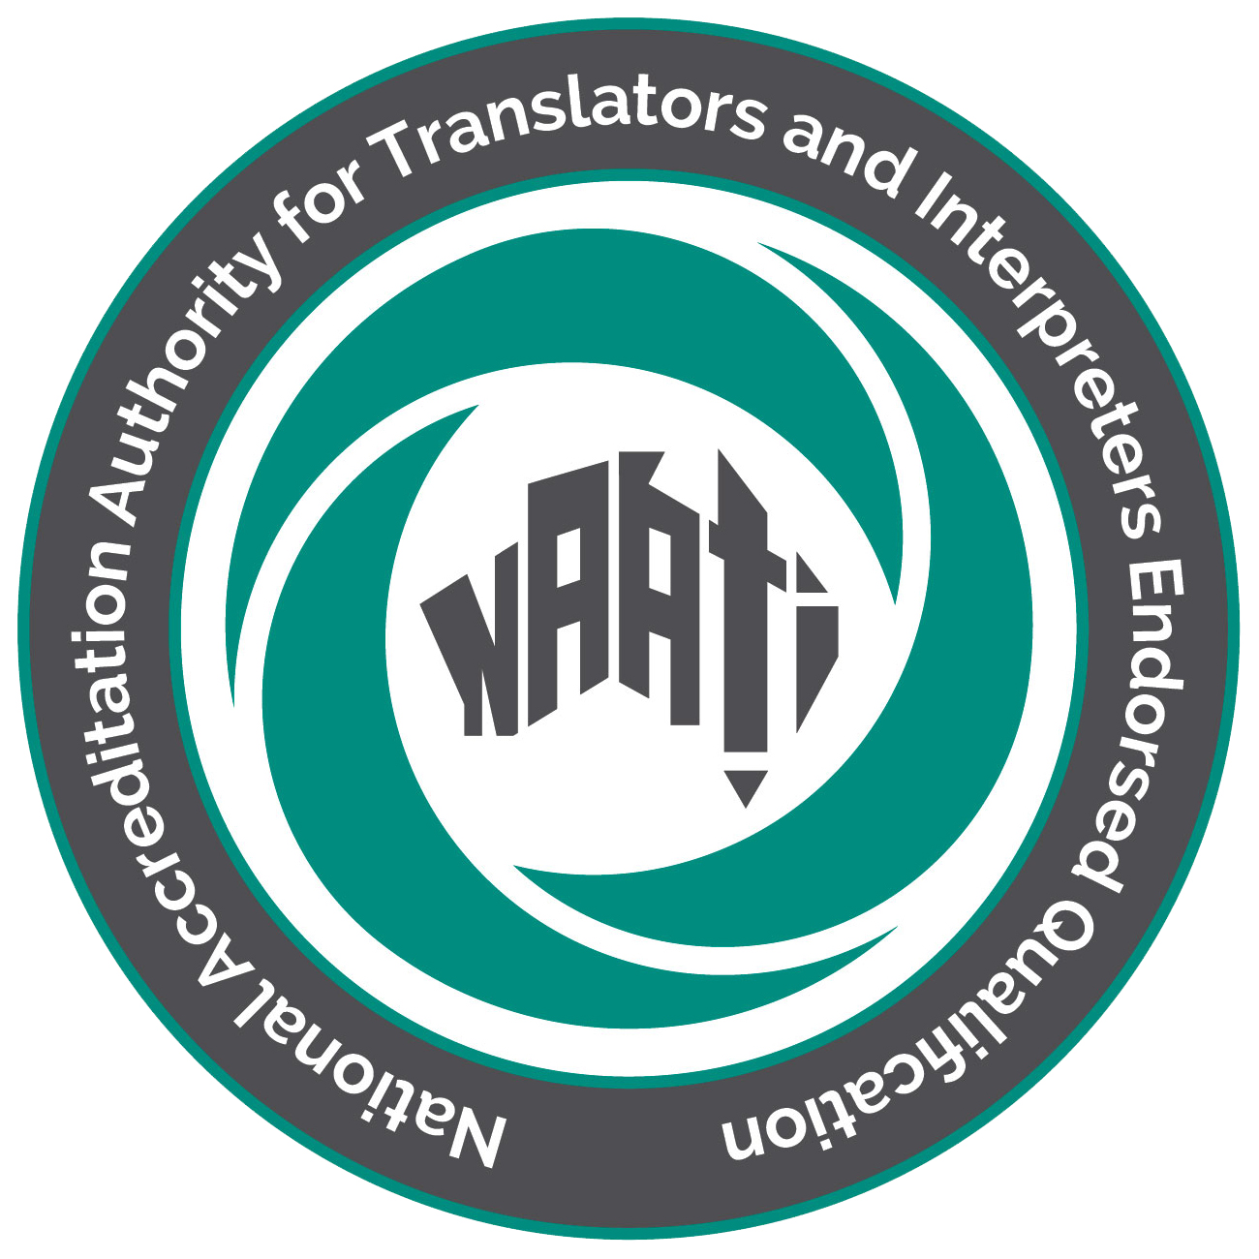
This program is endorsed by the National Accreditation Authority for Translators and Interpreters (NAATI). Students who successfully graduate from this qualification will be eligible to sit certification test for the: NAATI Certified Provisional Interpreter.
Course duration: 26 weeks (including reassessment, catch up class and holidays)
Schedule: Once contact session per week
Delivery mode: Live virtual class
Campus location and delivery site: 337-339 La Trobe Street, 338 Queen Street, Melbourne 3000 and Zoom virtual class
Entry requirements:

Applicants must satisfy all requirements as below:

- Satisfactory numeracy and literacy skills to undertake this course, or
- Mature age and have sufficient work experience in the interpreting industry to successfully
- undertake this course, or
- Satisfactory complete year 12.
- Proficient in Mandarin (speaking and listening skills)
Course Structure:
PSPTIS102 Apply codes and standards to ethical practice
PSPTIS104 Prepare to translate or interpret
PSPTIS112 Interpret in general dialogue settings
PSPTIS114 Manage interactions in general settings
PSPTIS115 Use routine subject area terminology in two languages
PSPTIS103 Build glossaries for translating and interpreting assignments
PSPTIS118 Use routine health terminology in two languages
PSPTIS119 Use routine legal terminology in two languages
PSPTIS116 Demonstrate routine language proficiency in different subjects and cultural contexts
PSPTIS113 Interpret in general monologue settings
PSPTIS117 Use routine education terminology in two languages
PSPTIS105 Conduct career planning

Assessment methods:
A variety of assessment methods will be used throughout the course, including: Observation of students performing a practical interpreting task/s, Role play, Written response.
Tuition and Non-Tuition fees: Please refer to the Fee Schedule.
Compliant statement:
GBCA is responsible for providing compliant training and assessment, and issuing of the AQF certification documentation for qualifications detailed in its scope of registration on the National Training Register (training.gov.au).
Course enquiries:
If you have any enquiries, please contact: enquiry@gbca.edu.au

Student support service contact:
Student Support Officer
E: Studentsupport@gbca.edu.au; T: 9041 3050
This factsheet should be read in conjunction with our Student Handbook and website www.gbca.edu.au. 